**Testing Document**

**Project Title: ChatU**

**Document Version: 1.0.0**

**Group ID: B4**

**Print date: 06/05/2023**

**Group Members:**

**DENG Haopeng 1155138409**

**Gu Zhehao 1155141578**

**LIU Zhixian 1155141612**

**ZHANG Haoxiang 1155141702**

**Selected Application Choice: Twitter**

**CSCI3100**

**Department of Computer Science and Engineering**

**The Chinese University of Hong Kong**

**Our Final Commented Code Available At:**

[**https://github.com/Gavin-OP/CSCI3100-ChatU.git**](https://github.com/Gavin-OP/CSCI3100-ChatU.git)

**Table of Content**

[**1.**](https://docs.google.com/document/d/1xZ0FqRn7u5rzUarNtmCkGzl-d8Ip93t4uWsdUpxH6BU/edit#heading=h.dzr2azrjgru8) **Test Plan** **2**

[**2.**](https://docs.google.com/document/d/1xZ0FqRn7u5rzUarNtmCkGzl-d8Ip93t4uWsdUpxH6BU/edit#heading=h.2swknetj94z) **Test case 2**

[2.1.](https://docs.google.com/document/d/1xZ0FqRn7u5rzUarNtmCkGzl-d8Ip93t4uWsdUpxH6BU/edit#heading=h.f829zgur838b) Client-Server Architecture test 2

2.1.1. Test if a client-server architecture can support multiple clients.

2.2. User-Management test 2

2.2.1. Test if a new user can sign up and own his personal profile.

2.2.2. Test if logged-in users are authorized to visit pages other than \login and \home

2.2.3. Test if a sign-up user can login or logout successfully.

2.3. Admin-User test 4

2.3.1. Test if an admin can list all tweets, comments and users.

2.3.2. Test if an admin can search for tweets, comments and users.

2.3.3. Test if an admin can delete tweets, comments and users.

2.3.4. Test if an admin can ban and unban users.

2.4. Application Requirement test 7

2.4.1. Test if a user can search for tweets and users.

2.4.2. Test if a user can enter the tweet detail page by clicking the tweet card.

2.4.3. Test if a loginned user can follow other loginned users.

2.4.4. Test if a loginned user can like or dislike a tweet.

2.4.5. Test if a loginned user can retweet a tweet.

2.4.6. Test if a loginned user can comment a tweet.

2.4.7. Test if a loginned user can favorite a tweet.

2.4.8. Test if a loginned user can post a tweet (can insert images).

2.4.9. Test if a loginned user can blacklist other loginned users.

2.4.10. Test if a loginned user can check his personal page and tweets he posted before, as well as

the user’s favorite tweets.

2.4.11. Test if a loginned user can check his blacklist, favorite list, follower list and following list.

2.4.12. Test if a loginned user can change his avatar, name, signature.

2.4.13. Test if a loginned user can see recommended contents including the following users’ tweets.

2.4.14. Test if a non-loginned user cannot do 2.4.3 to 2.4.13.

1. **TEST PLAN**

We will use blackbox testing as our test approach. As our software is a Twitter-like application, the features we test include client-server architecture, user signup, user login and logout, listing all or deleting some users by admin users, user/tweet/comment search, user following, liking or disliking tweets, commenting tweets, posting tweets, retweeting tweets, showing tweets of users followed, recommendation, and for each of these features, we test whether the actual output of the frontend match our expected output, and whether the backend APIs associated with this feature retrieve information and transfer data to the frontend as expected. The tools we use for testing are Postman for backend API testing and the Google chrome developer tools (which include the console, webpage element and network panels, etc.) for frontend testing. The testing requirements, specifically in terms of the software requirements, are react.js for frontend interface display, express.js for backend server hosting, and MongoDB for database connections and access. There are no worthy-to-mention hardware requirements, just use any modern personal computer or laptop.

1. **TEST CASE:**
   1. Client-Server Architecture test:
      1. Purpose: Test if a client-server architecture can support multiple clients.
         1. Inputs
         2. Expected Outputs & Pass/Fail Criteria
         3. Result
   2. User-Management test:
      1. Purpose: Test if a new user can sign up and own his personal profile.
         1. Inputs

{ {username:user1, email: user1@mail.com, password: 123456},

{username:User2, email: user1@mail.com, password: 123456}}

* + - 1. Expected Outputs

{Redirect to Home Page (Sign up successfully), Fail to sign up }

The website should handle both cases successfully.

* + - 1. Result

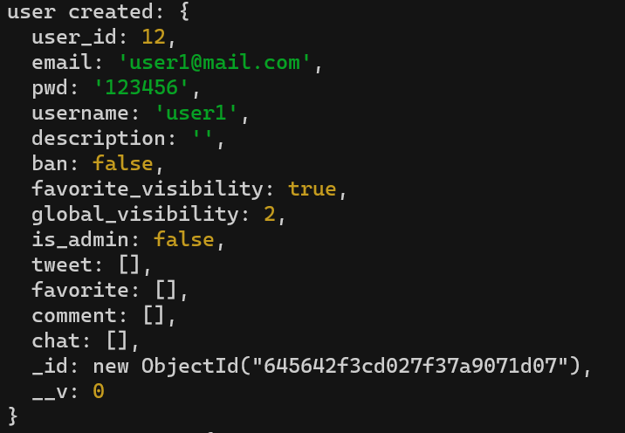 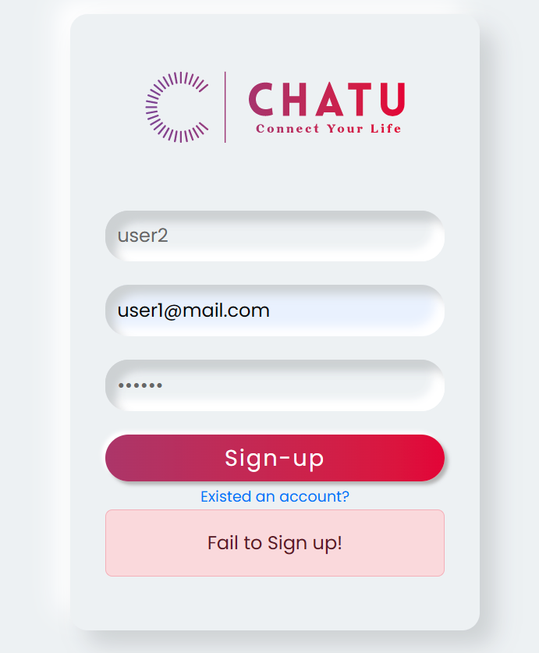

The actual output matches the expected output.

* + 1. Purpose: Test if logged-in users are authorized to visit pages other than \login and \home
       1. Input

{userId: 7}

* + - 1. Expected Output

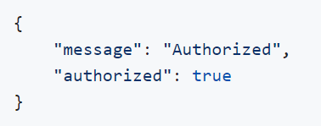

* + - 1. Result

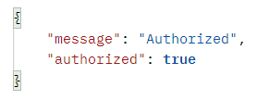

The actual output matches the expected output.

* + 1. Purpose: Test if a sign-up user can login or logout successfully.
       1. Inputs

{ {email: user1@mail.com, password: 654321},

{ email: user1@mail.com, password: 123456}}

* + - 1. Expected Output

{Wrong account/password, Redirect to Home Page (Login successfully)}

* + - 1. Result

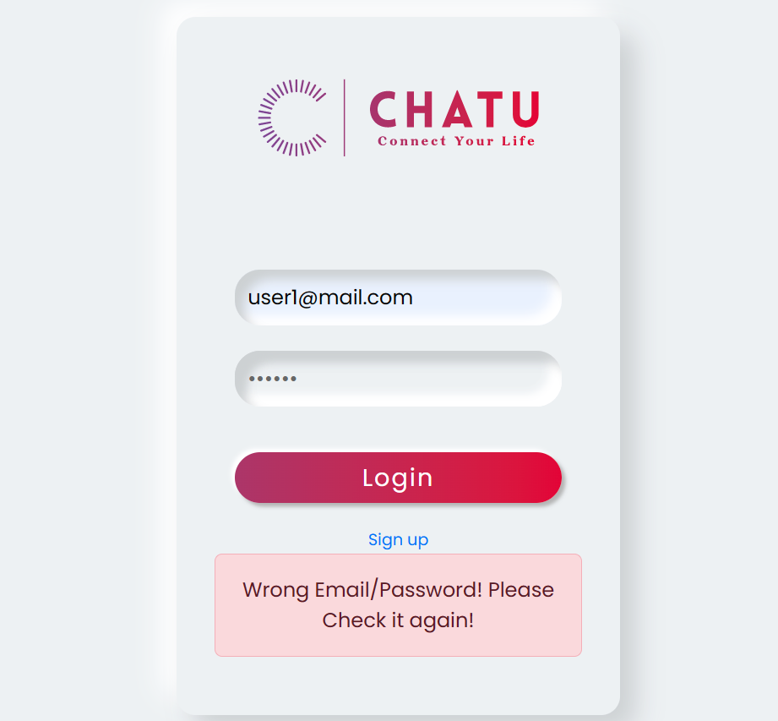 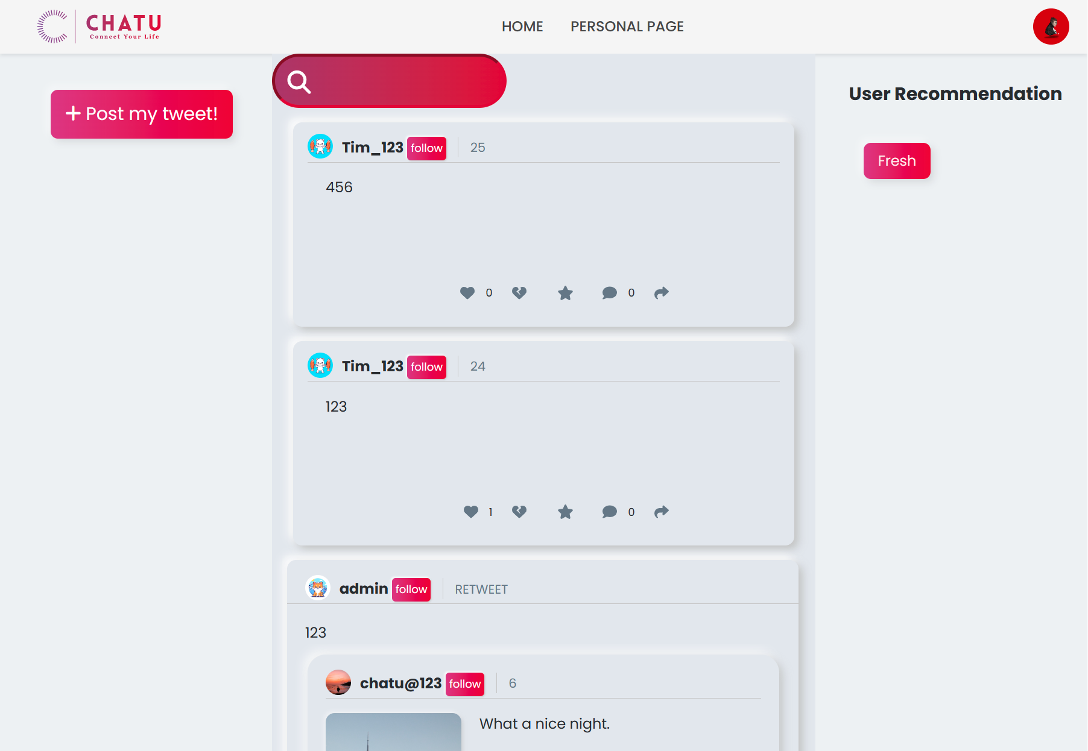

The actual output matches the expected output.

* 1. Admin-User test:
     1. Purpose: Test if an admin can list all tweets, comments and users.
        1. Input:

Log into the admin account with {email: “admin”, password: “admin”}, then click the “TWEET”, or “COMMENT”, or “USER” to view the list of all tweets, comments, users, respectively.

* + - 1. Expected Output: After clicking the “TWEET”, or “COMMENT”, or “USER” button, the frontend interface should display the list of all tweets, or comments, or users, respectively
      2. Result:

List of tweets:

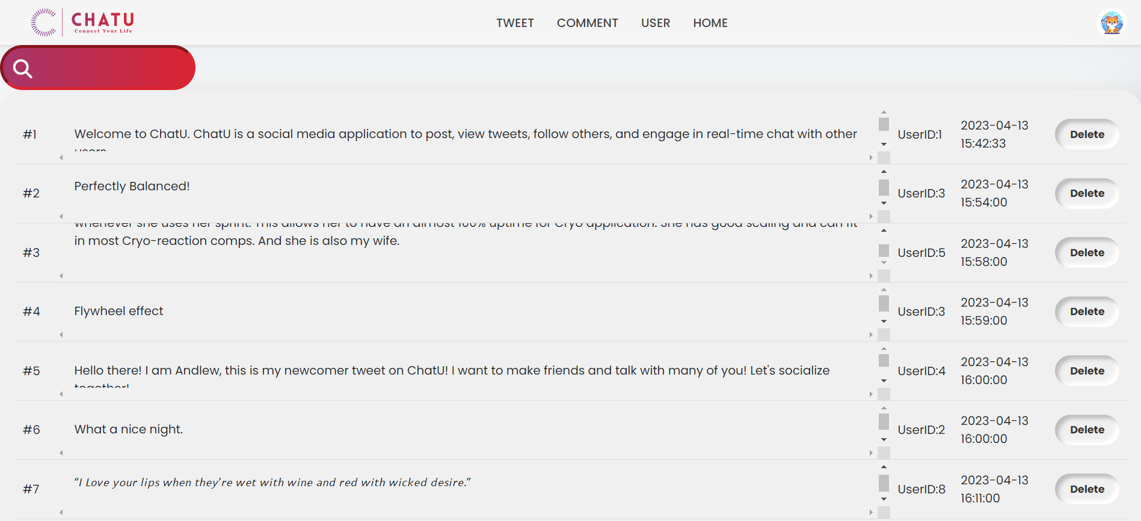

List of comments:

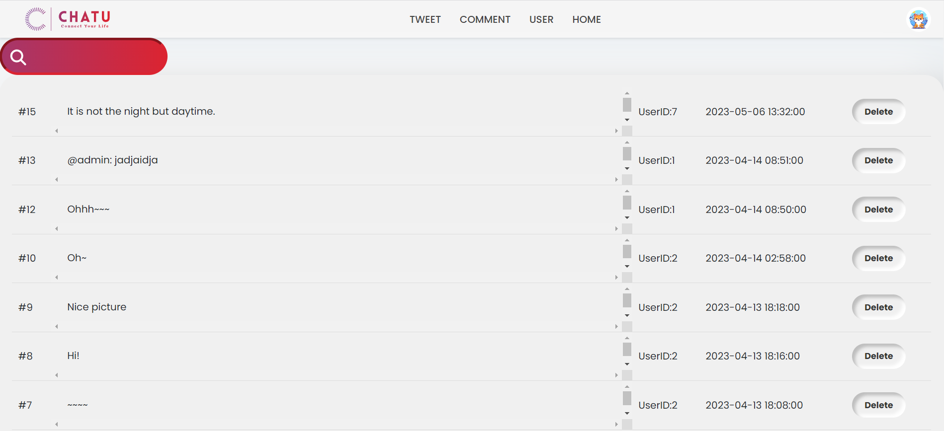

List of users:

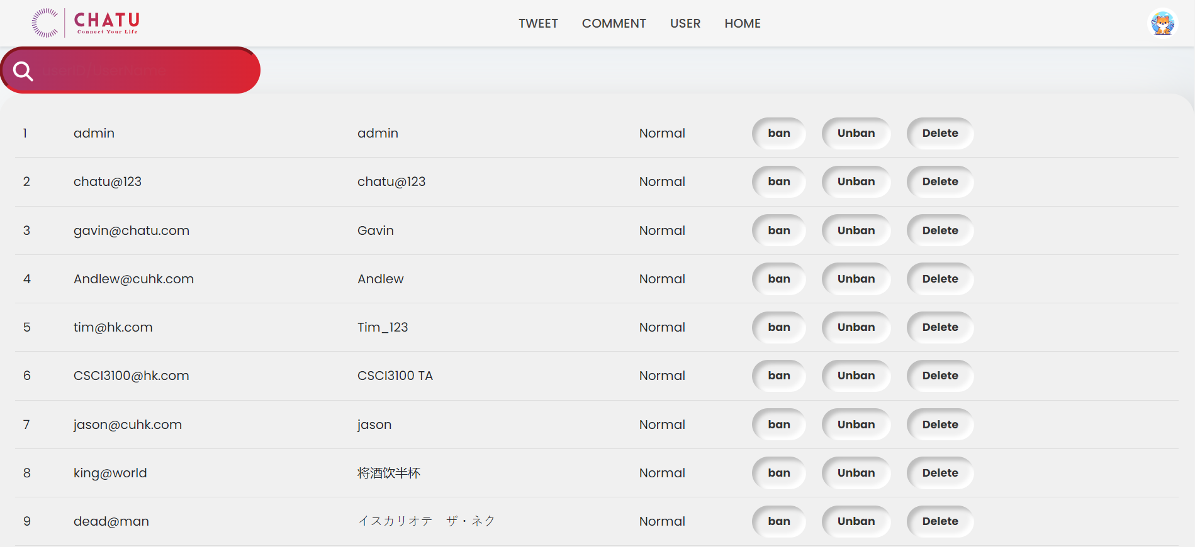

The actual outputs above match our description of expected outputs.

* + 1. Purpose: Test if an admin can search for tweets, comments and users.
       1. Input:

For tweet search: In the search bar of the “TWEET” page of the admin account, search with the input {txt: “hat”}. For user search: In the search bar of the “USER” page of the admin account, search with the input {txt: “so”}. For comment search: In the search bar of the “COMMENT” page of the admin account, search with the input {txt: “th”}.

* + - 1. Expected Output: For the tweet search with {txt: “hat”}, the frontend interface should list all tweets whose content contain the substring “hat”. For the user search with {txt: “so”}, the frontend interface should list all users whose usernames contain the substring “so”. For the comment search with {txt: “th”}, the frontend interface should list all comments whose contents contain the substring “th”.
      2. Result:

For the tweet search

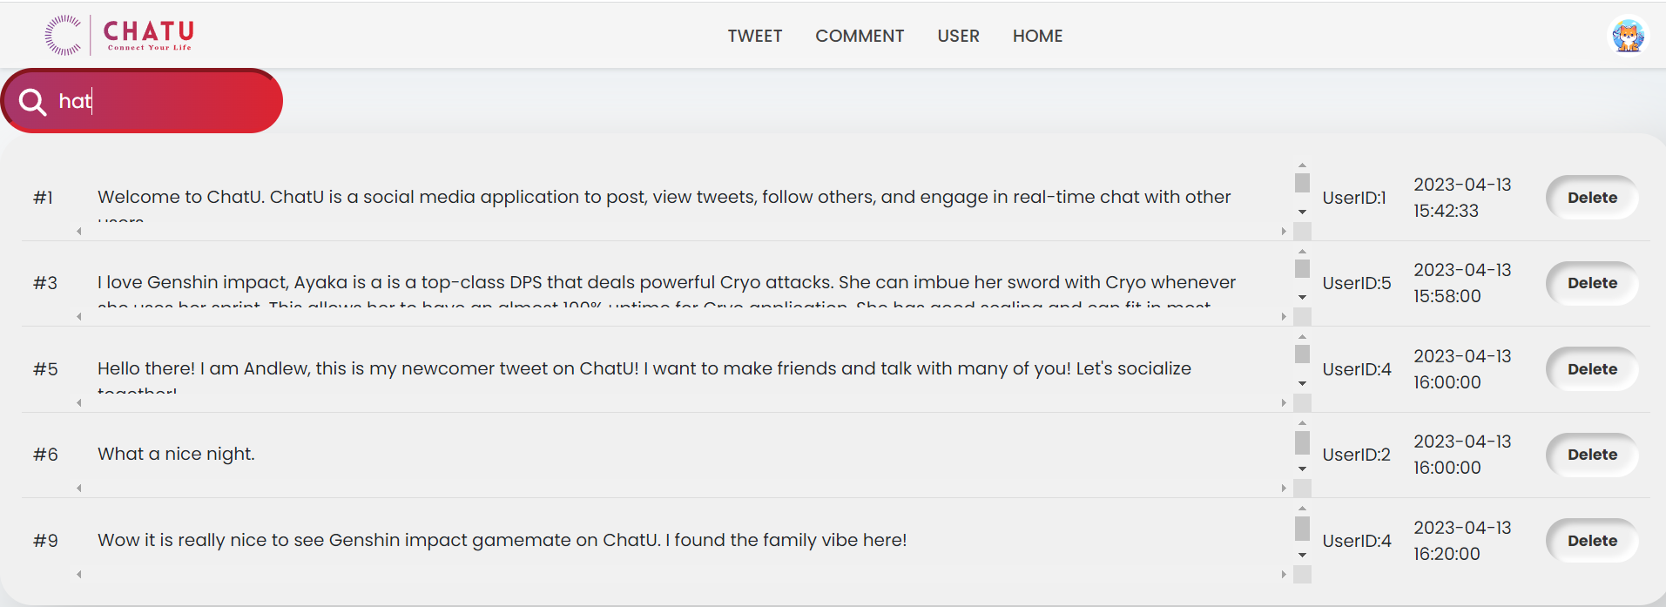

For the user search:

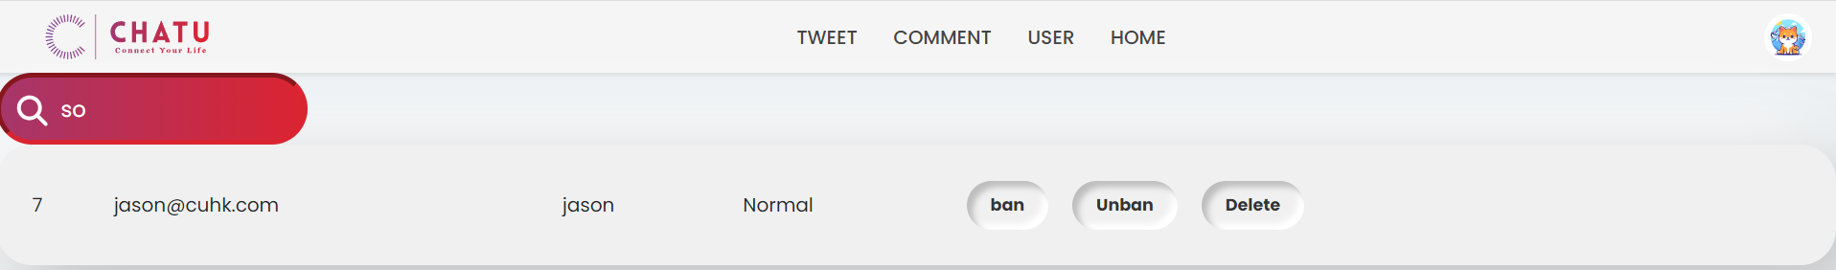

For the comment search:

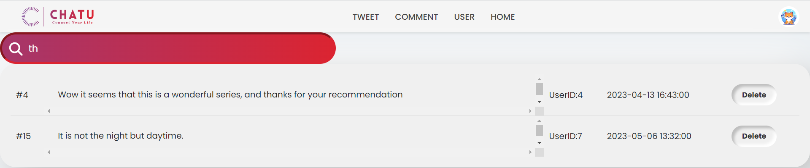

The actual output above matches our description of expected output.

* + 1. Purpose: Test if an admin can delete tweets, comments and users.
       1. Input:

Click the “delete” button.

* + - 1. Expected Output: The deleted item will be removed. And an alert bar shows the information: “Tweet removed successfully.”
      2. Result:(test for deleting tweet, three delete functions are the same)

Before deleting:

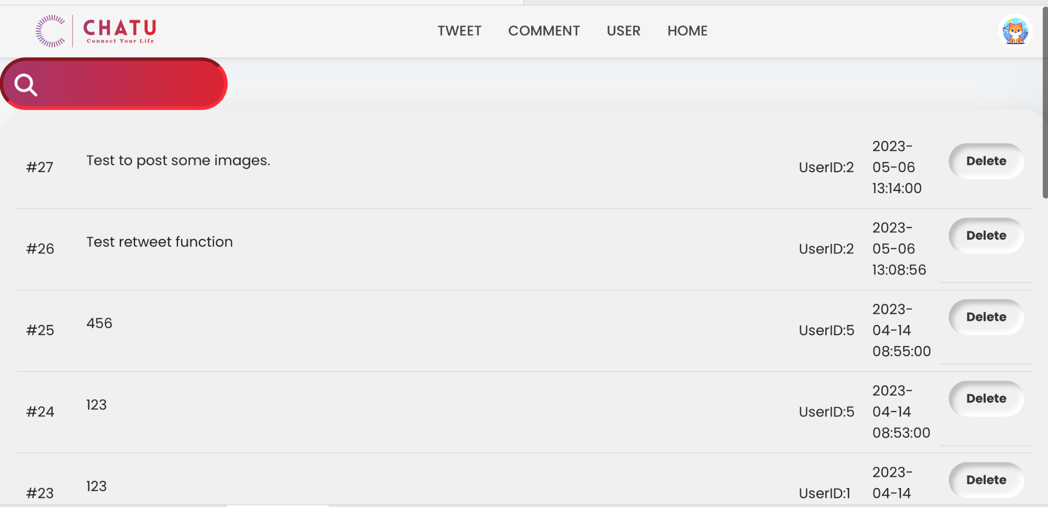

After deleting (TweetID 27):

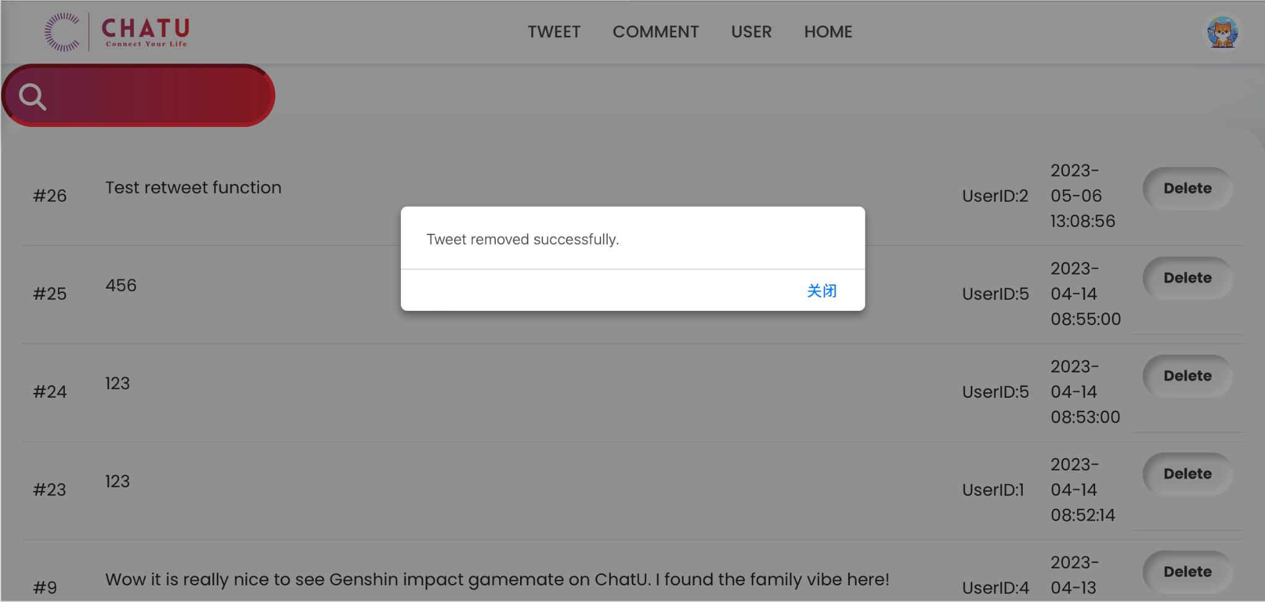

* + 1. Purpose: Test if an admin can ban and unban users.
       1. Input: For banning a user, click the “ban” button, as shown below, corresponding to a user



For unbanning a user, click the “unban” button, as shown below, corresponding to a user:



* + - 1. Expected Output: After clicking the “ban” button, the status of this user will change from “Normal” to “Banned”. After clicking the “unban” button, the status of this user will change from “Banned” to “Normal”.
      2. Result:

After clicking the “ban” button:



After clicking the “unban” button:



The actual output above matches our description of expected output.

* 1. Application Requirement test:
     1. Purpose: Test if a user can search for tweets and users.
        1. Input

{ 4 } in the search bar

* + - 1. Expected Output

All the tweets posted by user with userID: 4, and tweets with “4” as a part of content.

* + - 1. Result

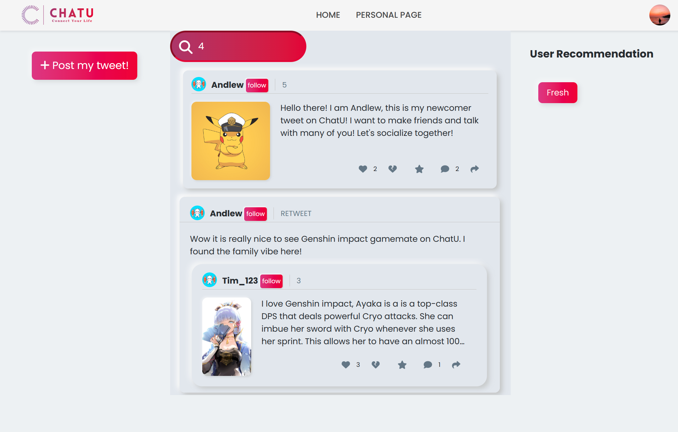

* + 1. Purpose: Test if a user can enter the tweet detail page by clicking the tweet card.
       1. Input

Click the tweet with tweetID: 5

* + - 1. Expected Output

Show the detailed page of tweet

* + - 1. Result

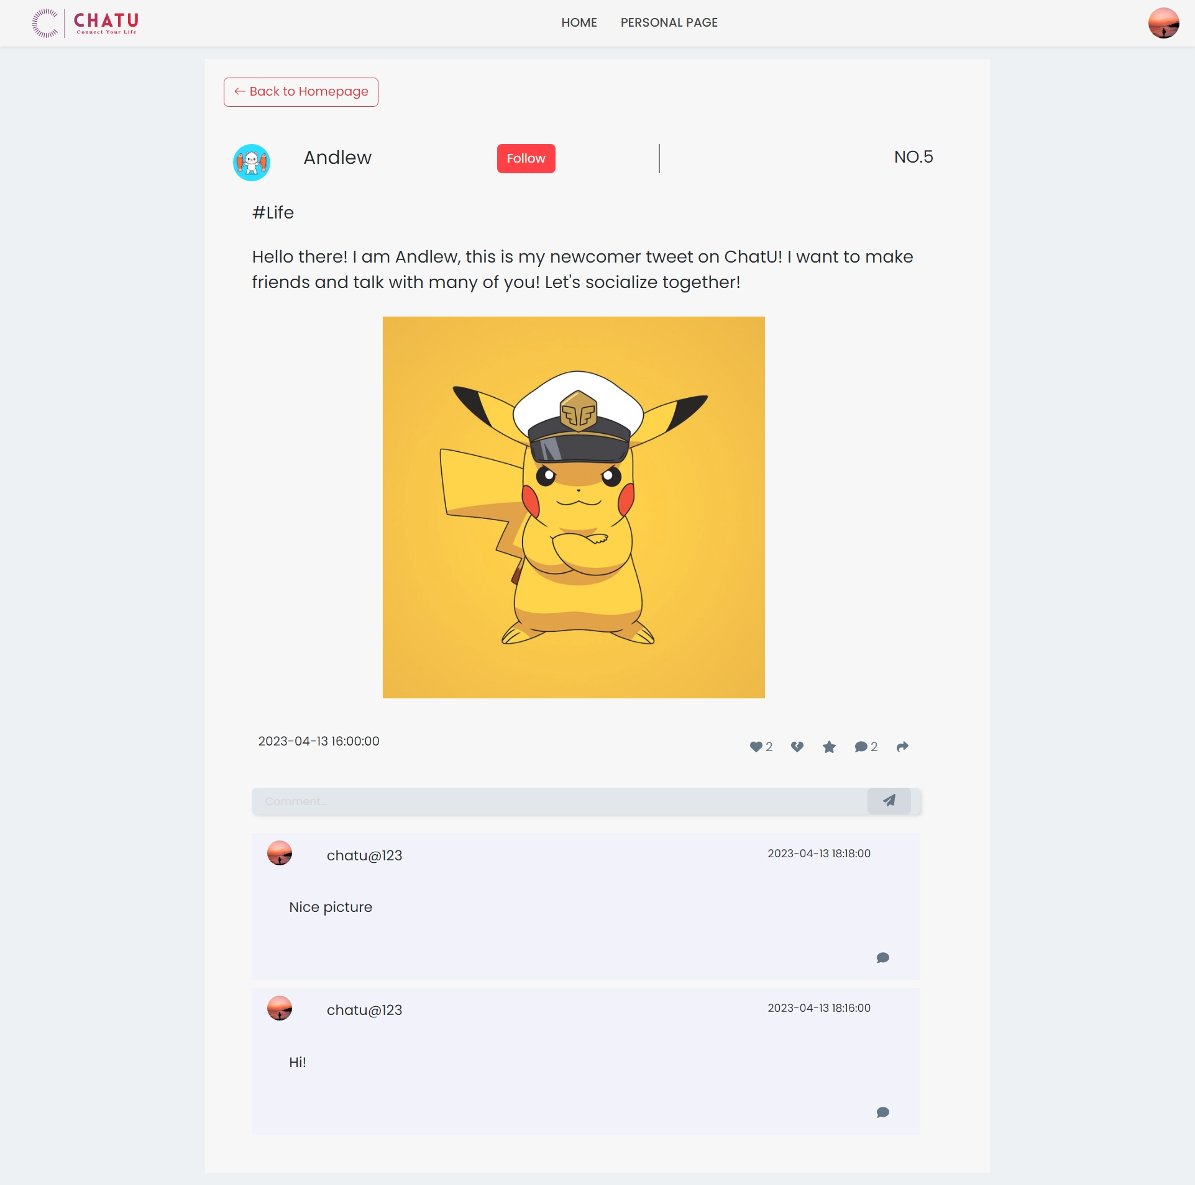

* + 1. Purpose: Test if a loginned user can follow other loginned users.
    2. Purpose: Test if a loginned user can like or dislike a tweet.
       1. Input

Click the like button first, then dislike button

* + - 1. Expected Output

The like button should be active after first clickment, the count of like will increase at the same time. The like button will be inactive and dislike button will be active, the count should decrease by 2 (from like to dislike)

* + - 1. Result

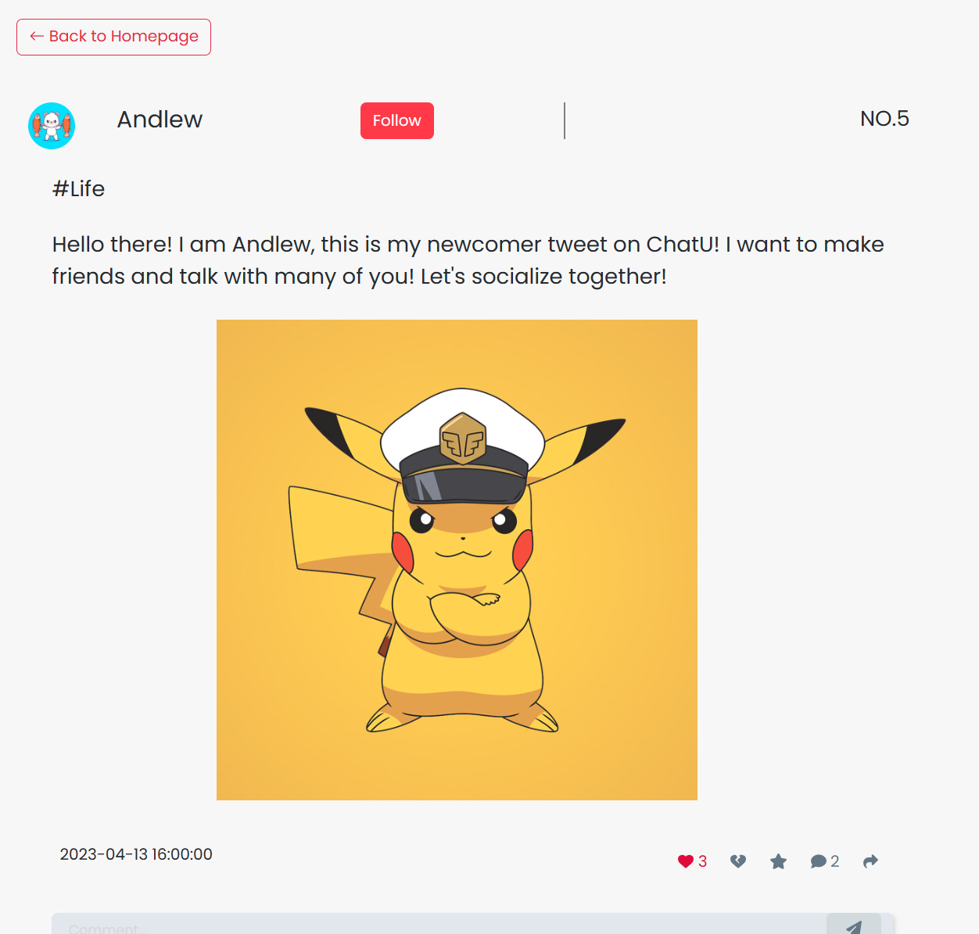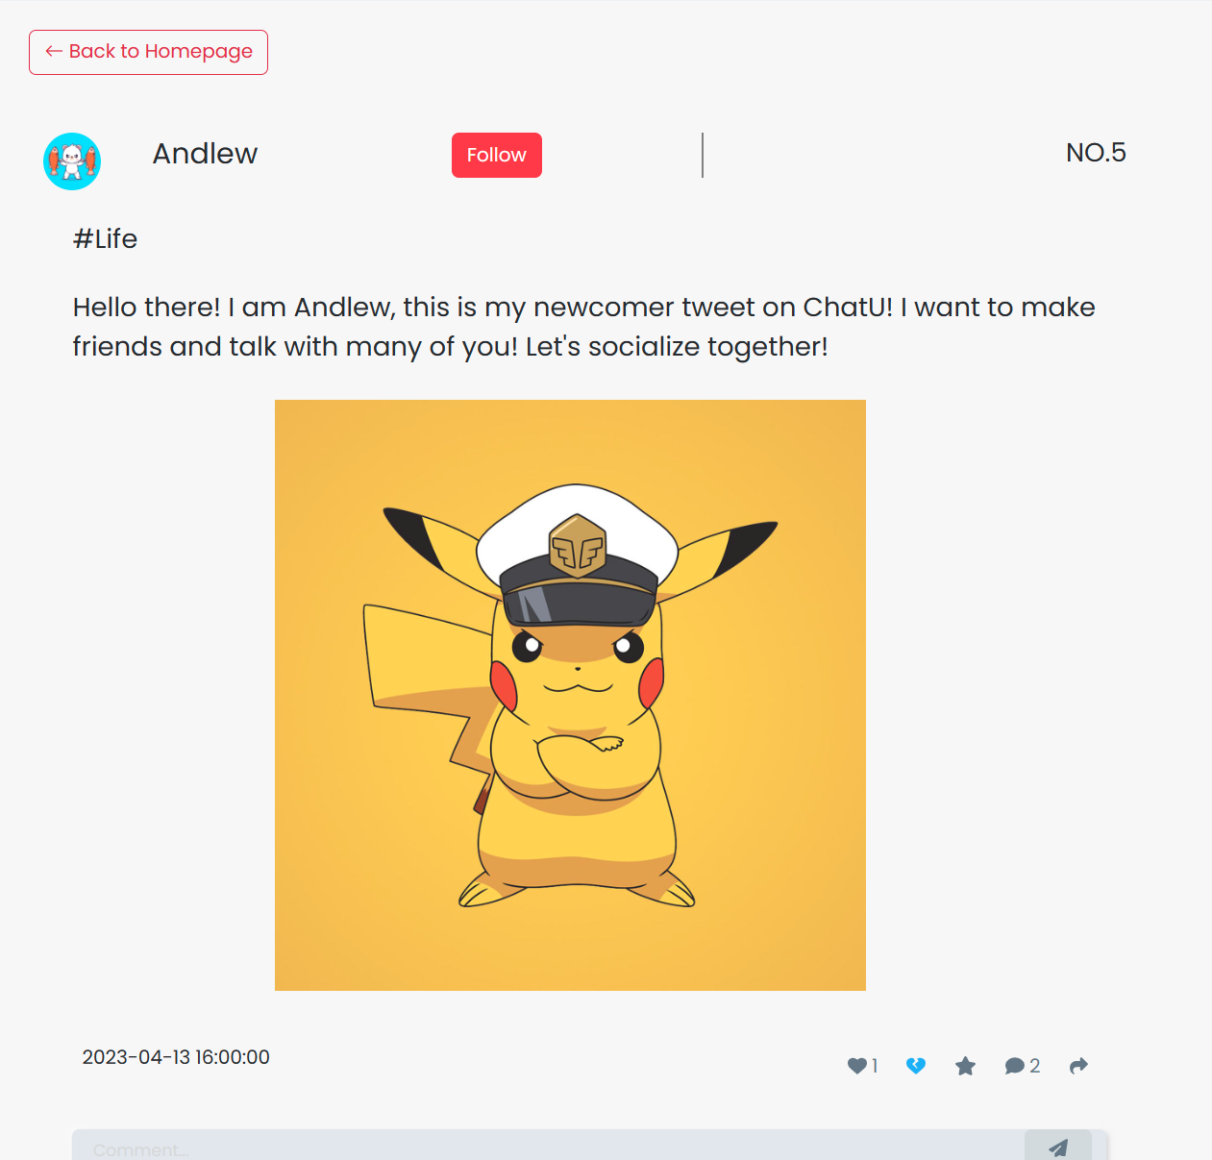

* + 1. Purpose: Test if a loginned user can retweet a tweet.
       1. Input

Click the retweet button. Then post it.

* + - 1. Expected Output

Redirect to the retweet page, with a tweet card displaying this tweet. After posting, there should be a retweet in the Home Page.

* + - 1. Result

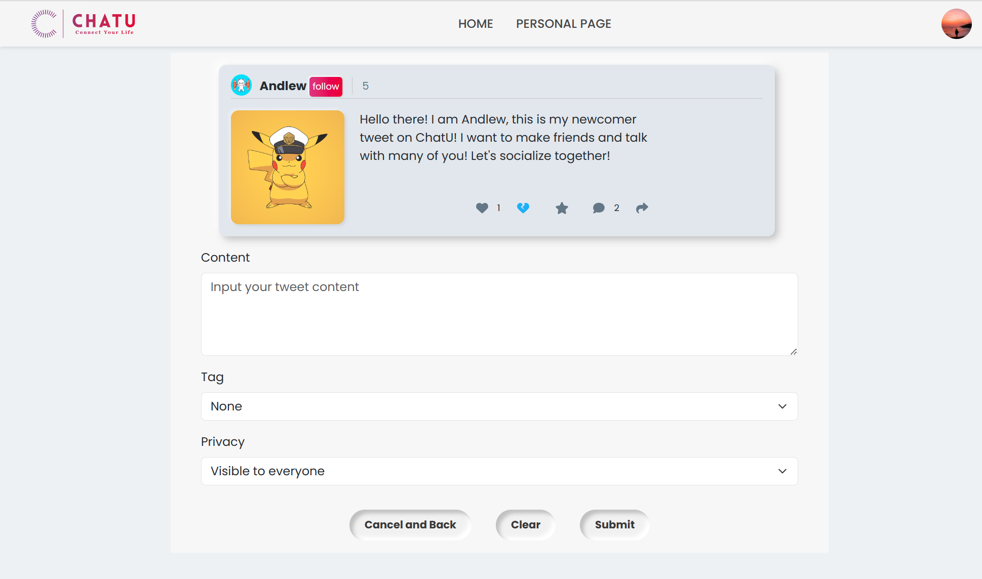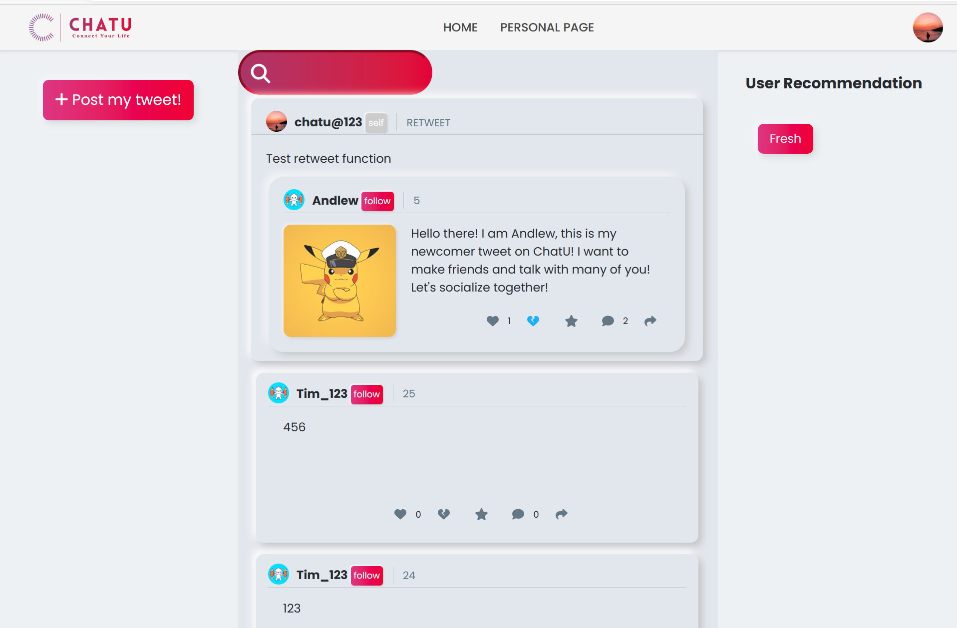

* + 1. Purpose: Test if a loginned user can comment a tweet.
       1. Input:
       2. {tweet_id: 6, content: “It is not the night but daytime.”, time: Date}, where Date is a time-format variable that stores the time at which this comment is sent. This input corresponds to clicking the “paper plant” button (i.e., the send-comment button) in the screenshot below:
       3. Expected Output:

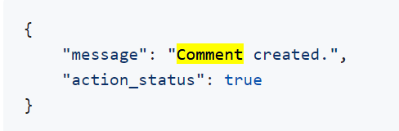

* + - 1. Result:

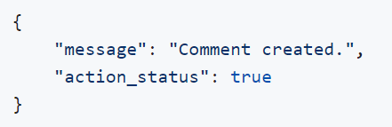

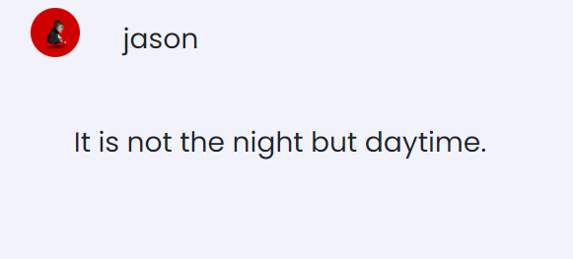

The actual output matches the expected output.

* + 1. Purpose: Test if a loginned user can favorite a tweet.
       1. Input:

{loggedInUserId: 7, tweetId: 2}, which corresponds to clicking the “star” icon of the tweet below with tweetId 2:

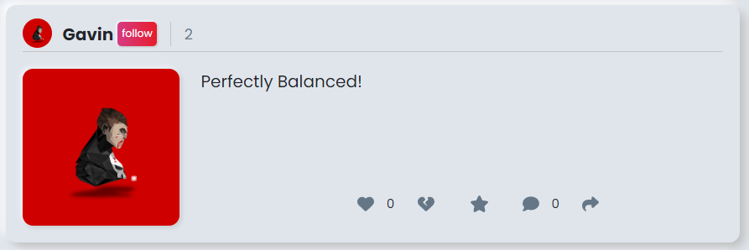

* + - 1. Expected Output:

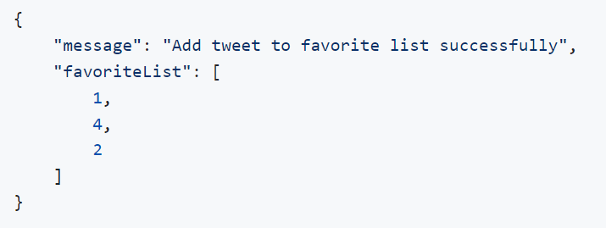

* + - 1. Result:

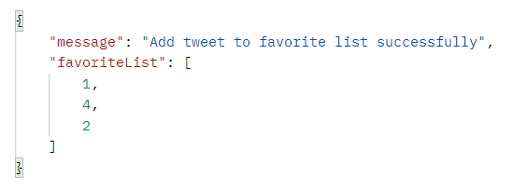

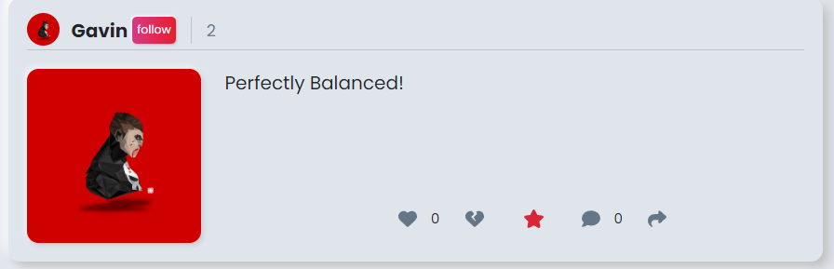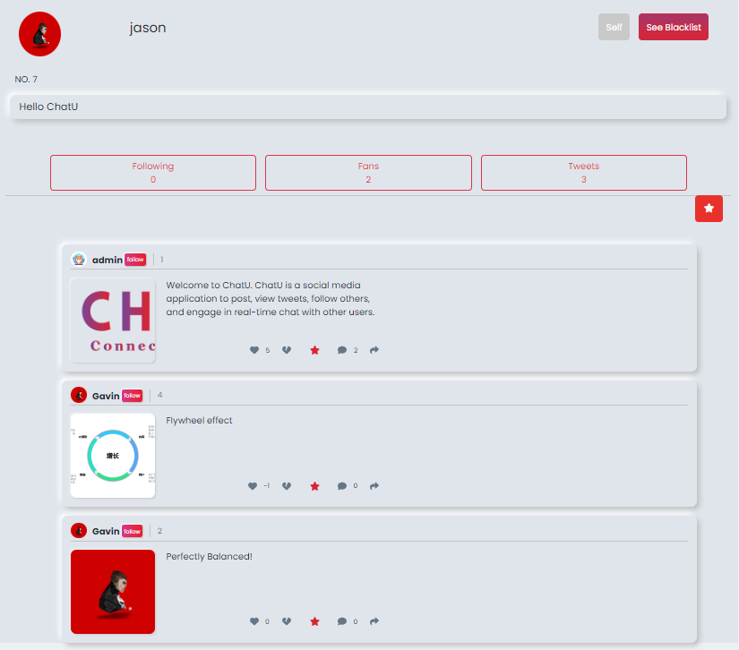

The actual output matches the expected output.

* + 1. Purpose: Test if a loginned user can post a tweet (can insert images).
       1. Input

Click the Post button in the Home Page, then redirect to the Post page. Post a new tweet with 3 images.

* + - 1. Expected Output

The new tweet should appear in the Home Page after posting.

* + - 1. Result

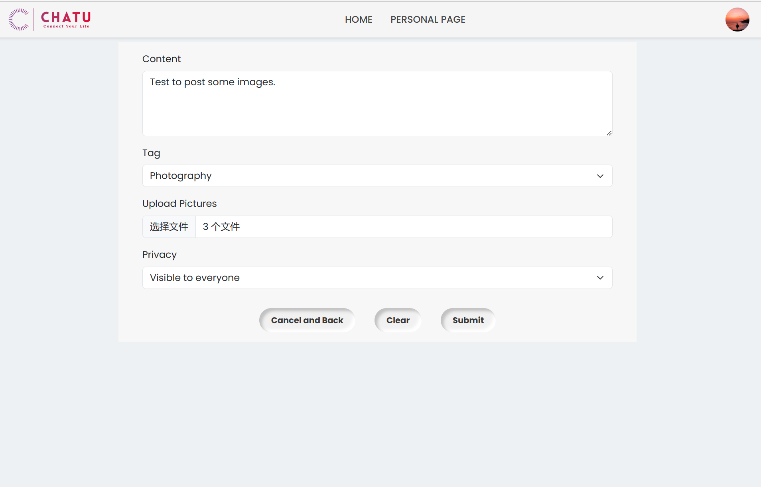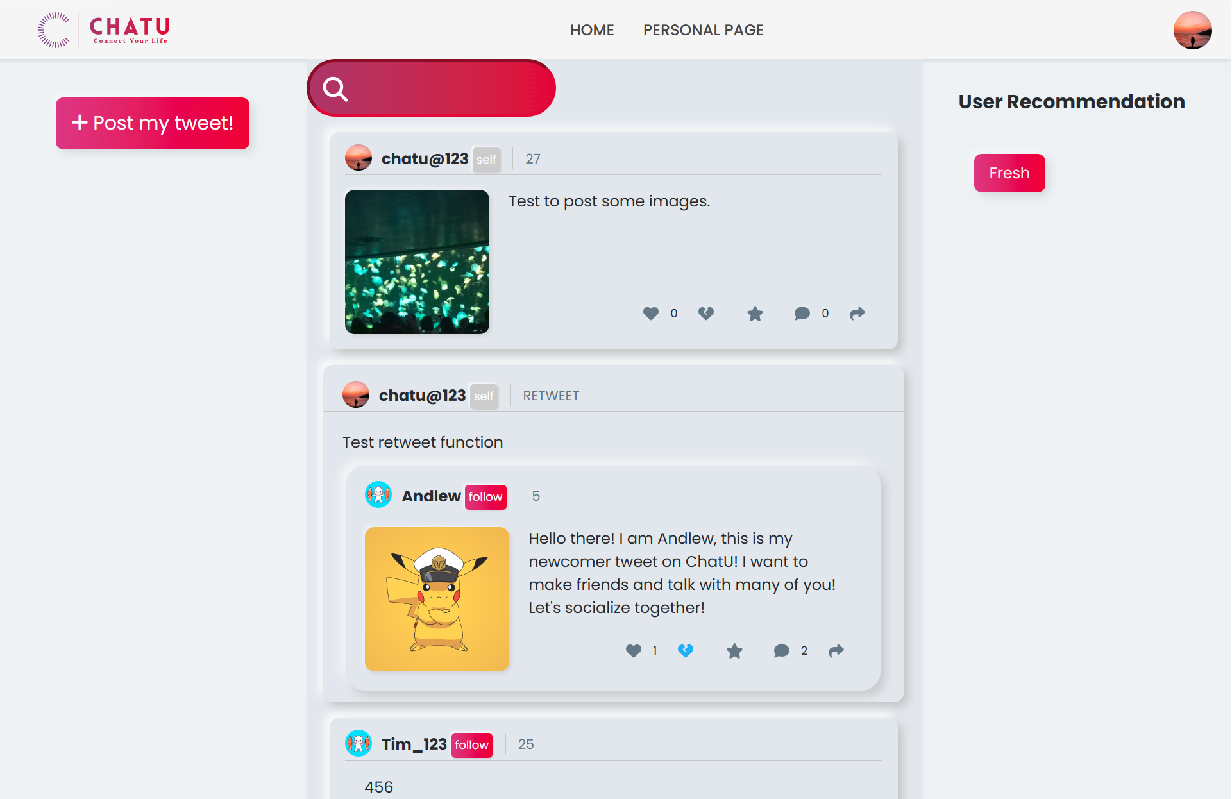

* + 1. Purpose: Test if a loginned user can blacklist other loginned users.
       1. Input

{loggedInUserId: 7, userIdToAdd: 2}, which corresponds to clicking the “Add to Blacklist” button in the screenshot below:

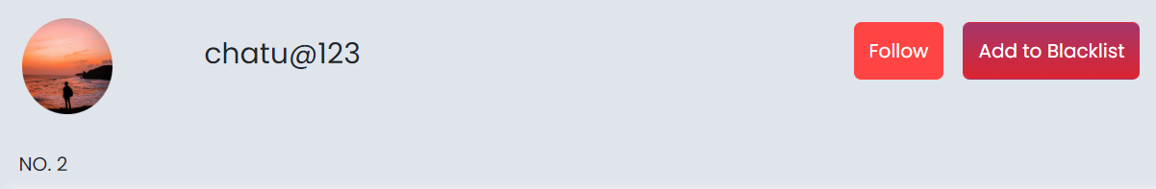

* + - 1. Expected Output

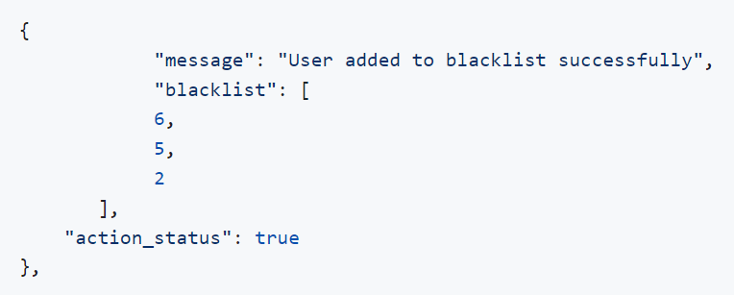

* + - 1. Result

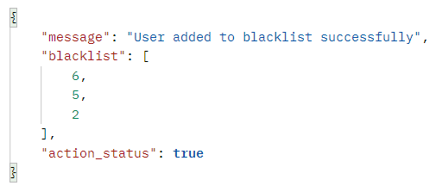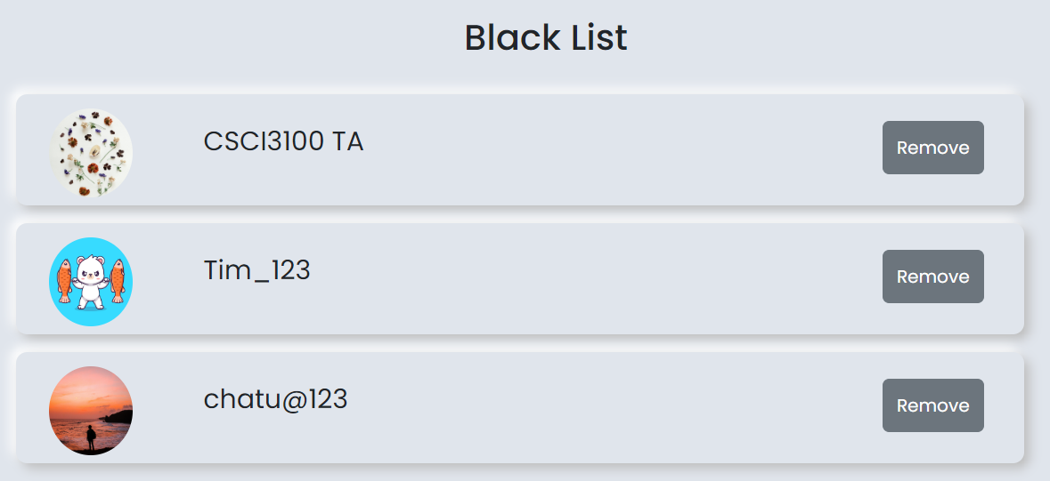

The actual output matches the expected output.

* + 1. Purpose: Test if a loginned user can check his personal page and tweets he posted before, as well as the user’s favorite tweets.
       1. Input

Click the Personal Page button on the top to see our own page, click the avatar in one tweet to enter the personal page of the poster. Click the star button.

* + - 1. Expected Output

Redirect to the personal page and can see all this user’s post. After clicking the star button, there should be the user’s favorite list.

* + - 1. Result

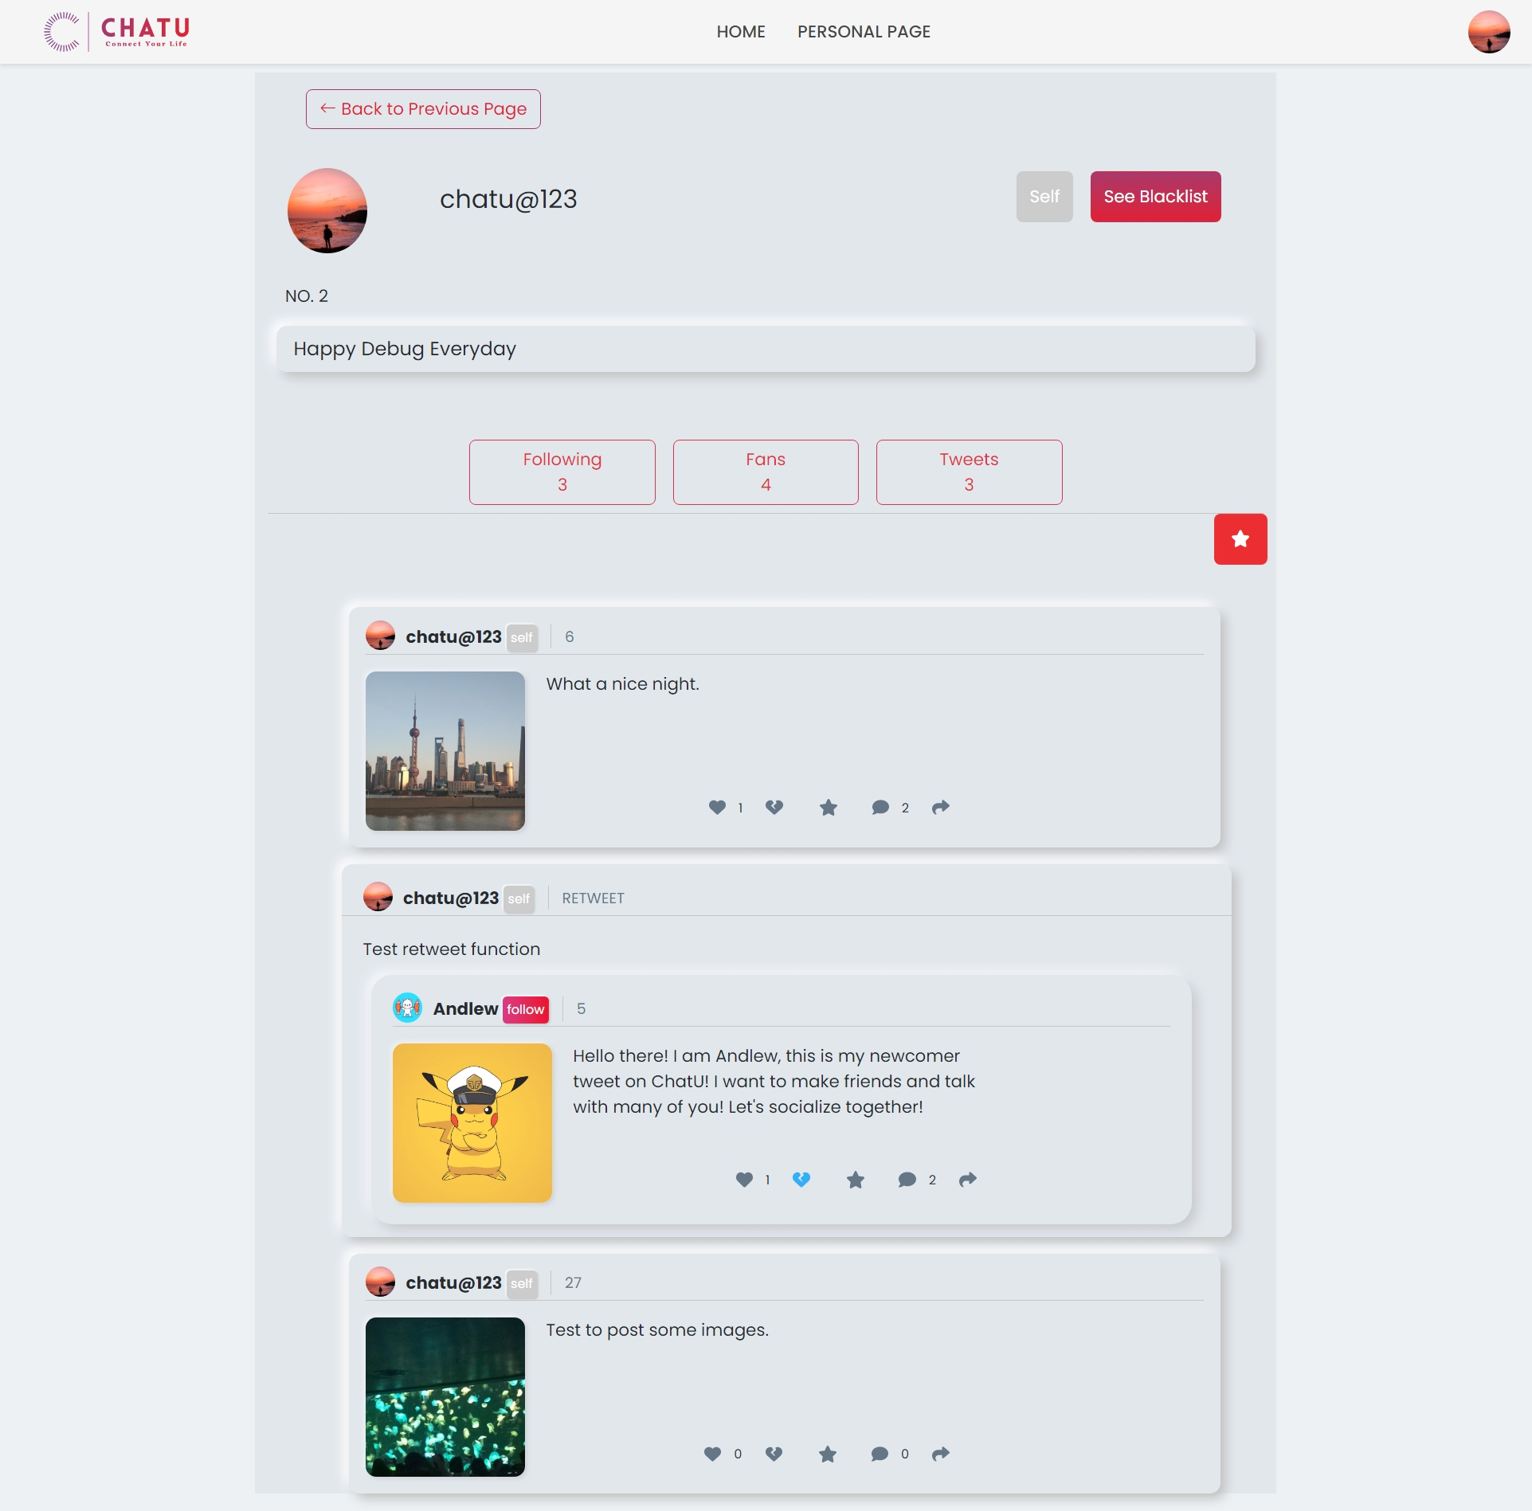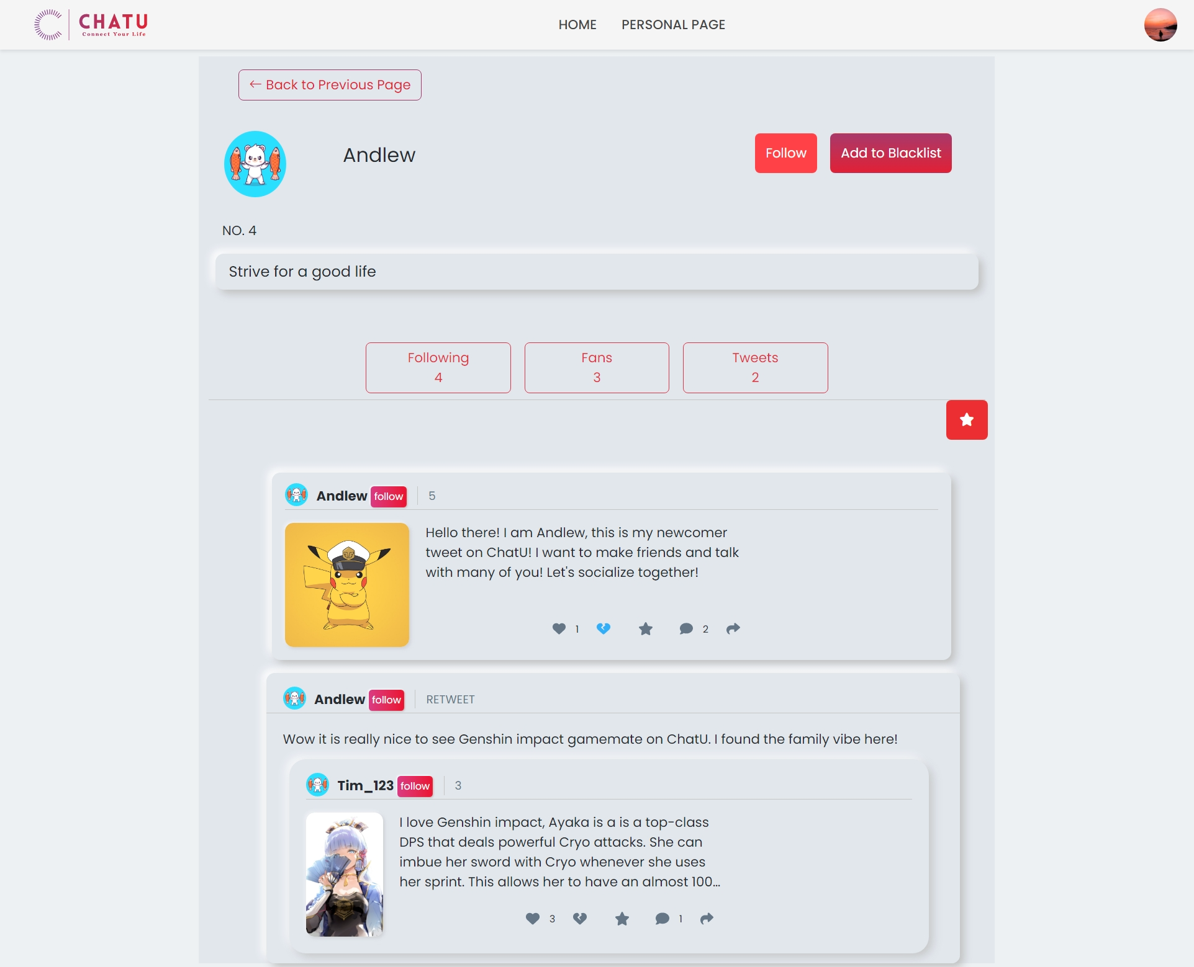

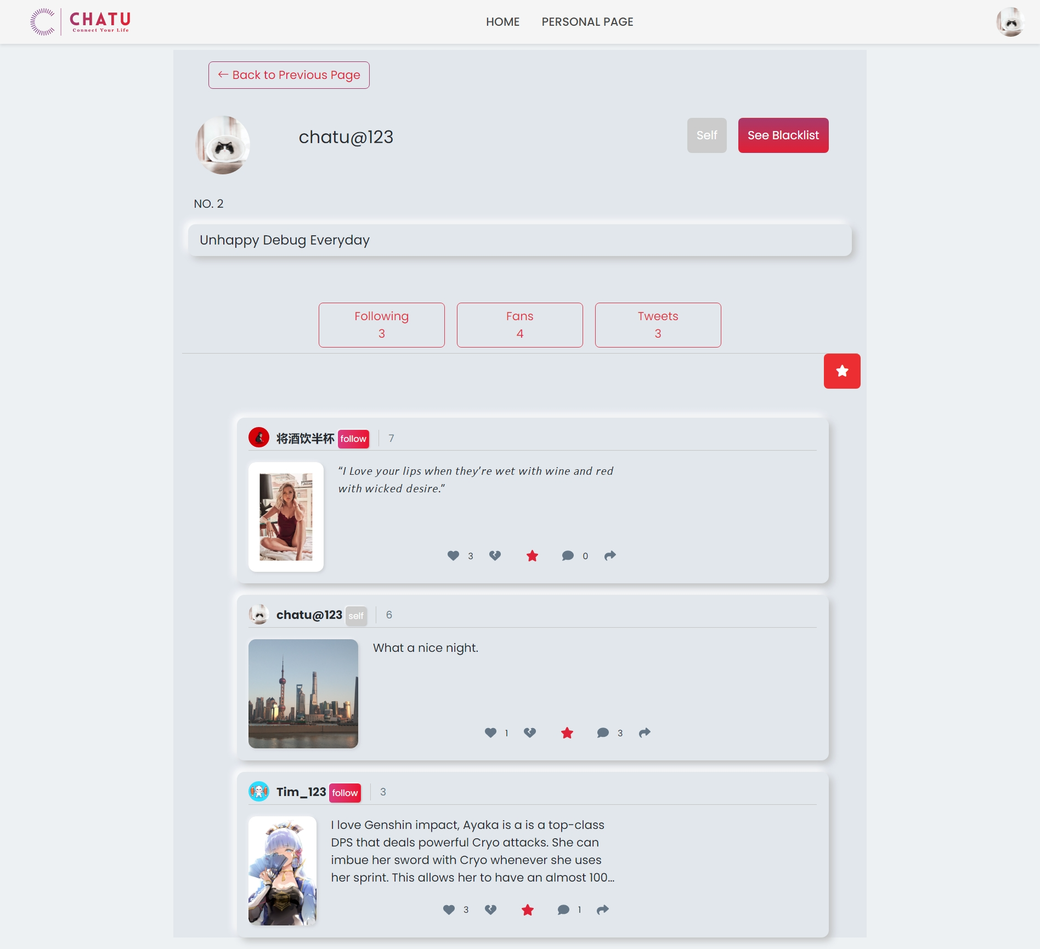

* + 1. Purpose: Test if a loginned user can check his blacklist, favorite list, follower list and following list.
       1. Input

Click the Following, Fans, See Blacklist button one by one.

* + - 1. Expected Output

See the Following list, fan list, and blacklist page.

* + - 1. Result

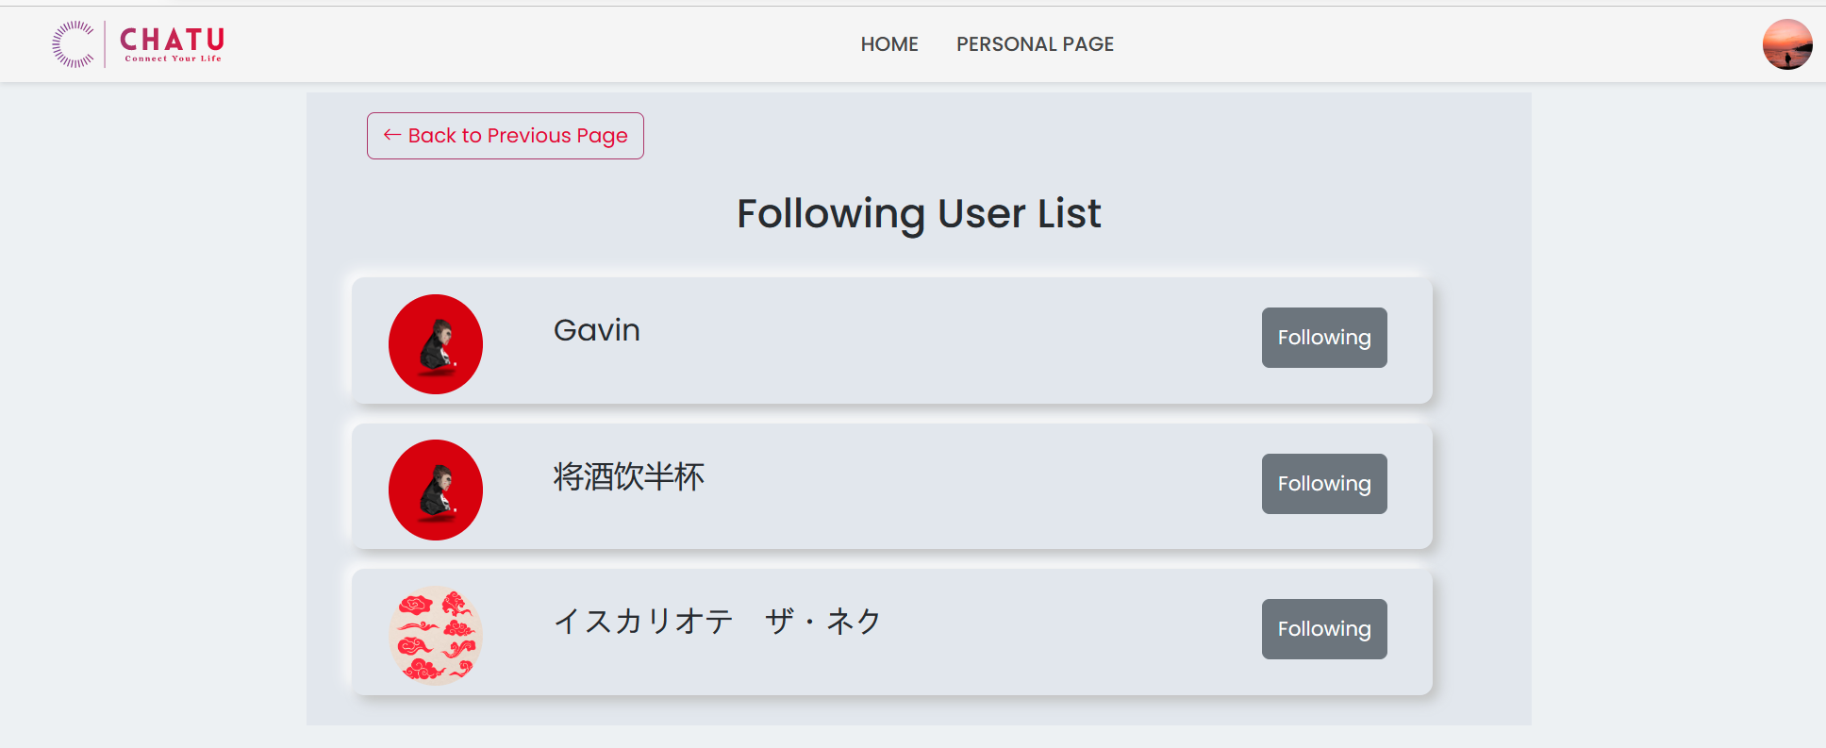

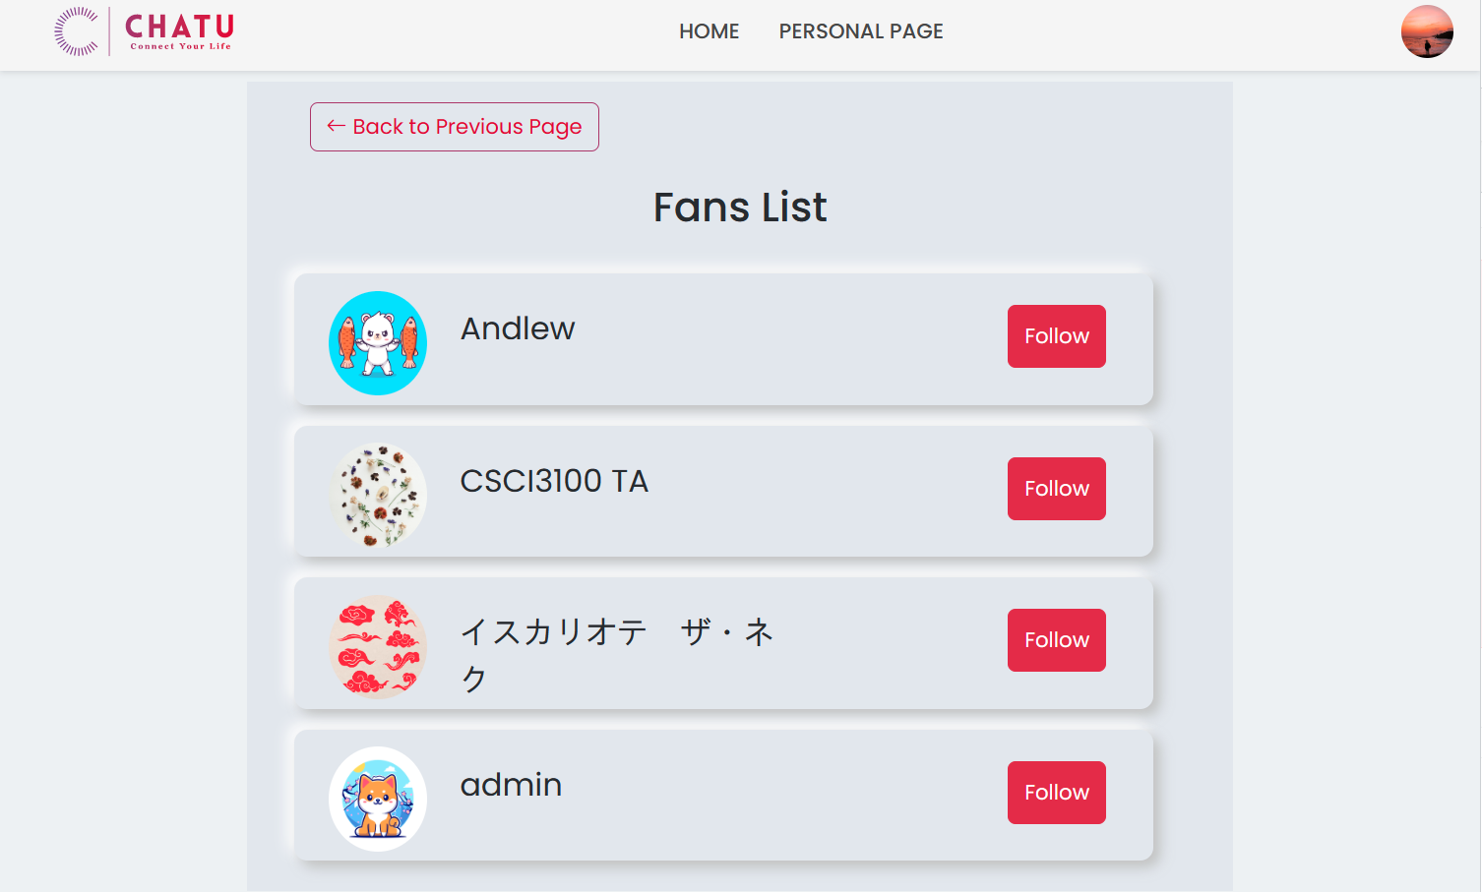

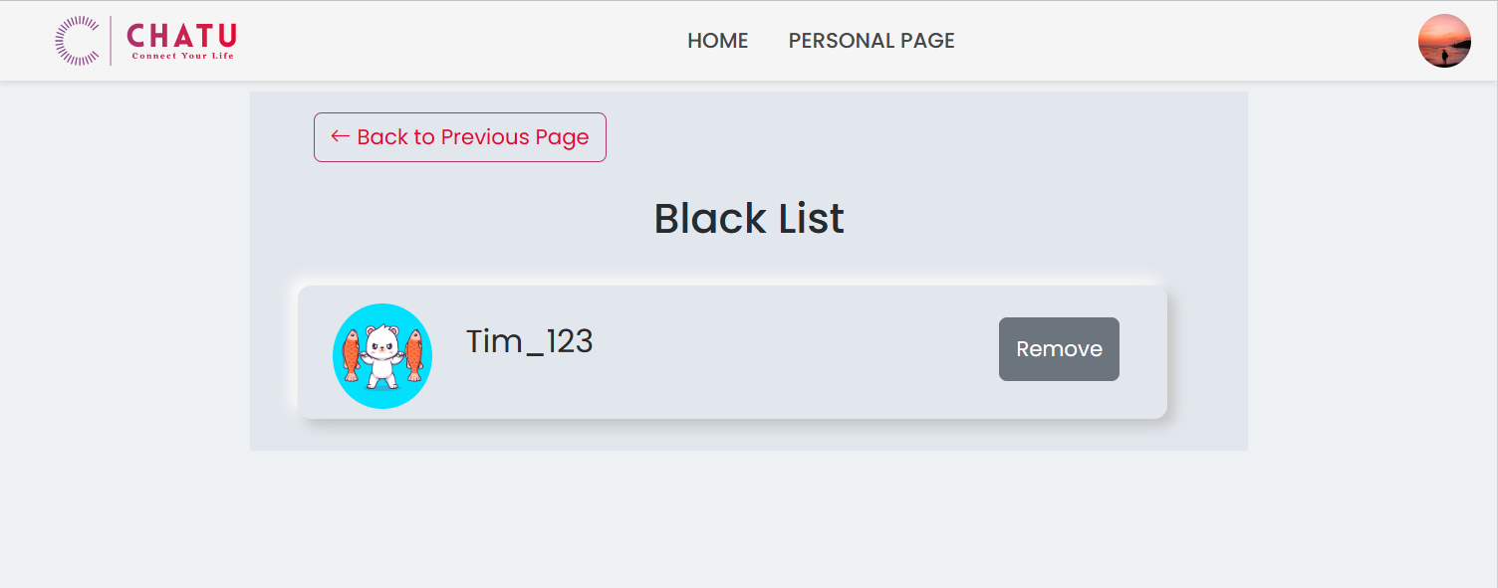

* + 1. Purpose: Test if a loginned user can change his avatar, name, signature.
       1. Input

Move the mouse on the avatar in the top-right, then click the setting page. Change some information.

* + - 1. Expected Output

The user information will change.

* + - 1. Result

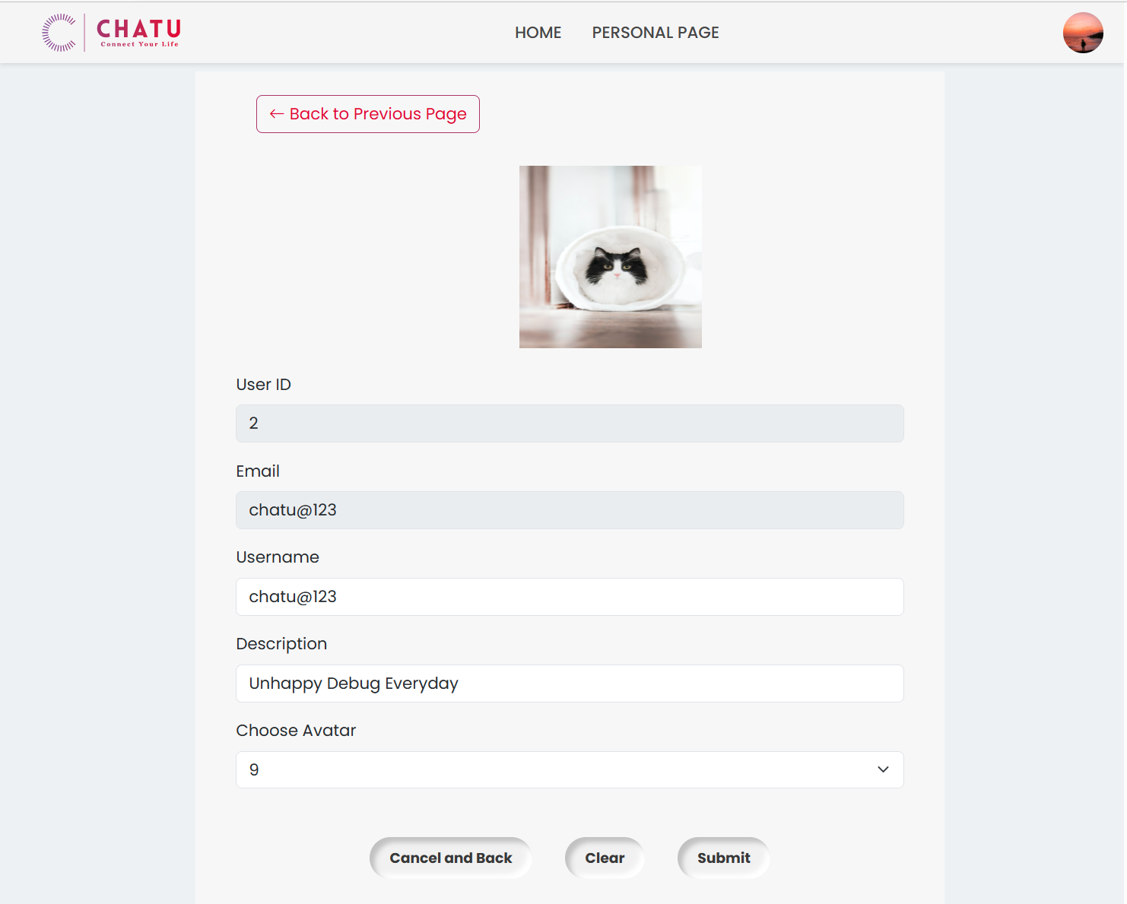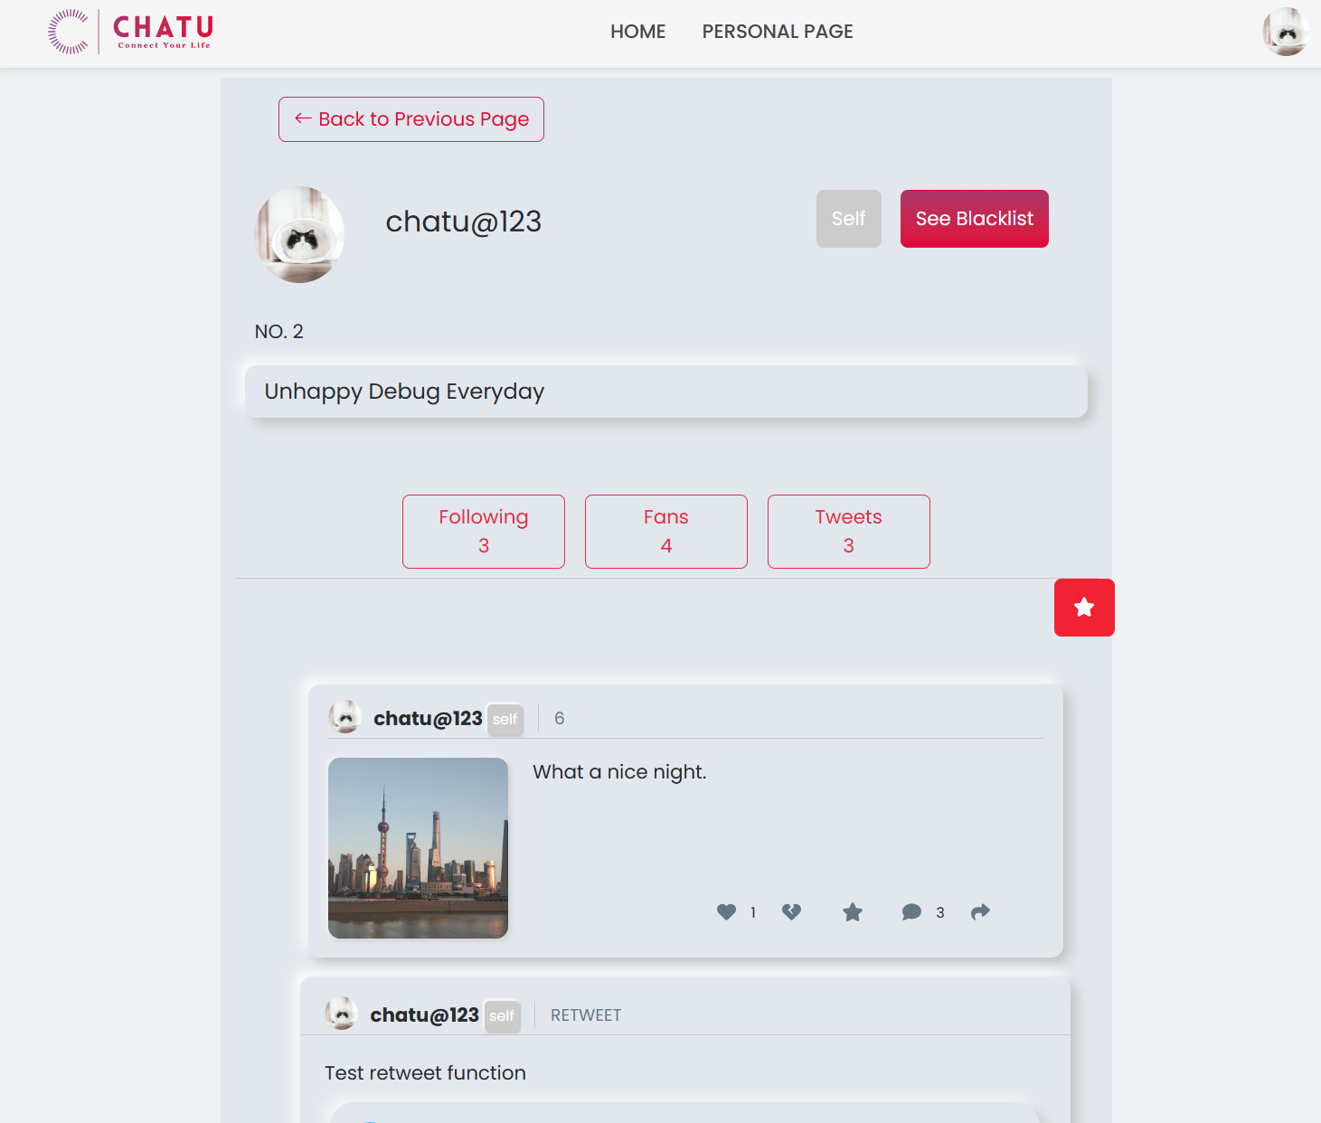

* + 1. Purpose: Test if a loginned user can see recommended contents including the following users’ tweets.
       1. Input

Users should always see recommended content at the homepage. Click the Fresh button to get two recommended users.

* + - 1. Expected Output

There will be two users who haven't followed yet.

* + - 1. Result

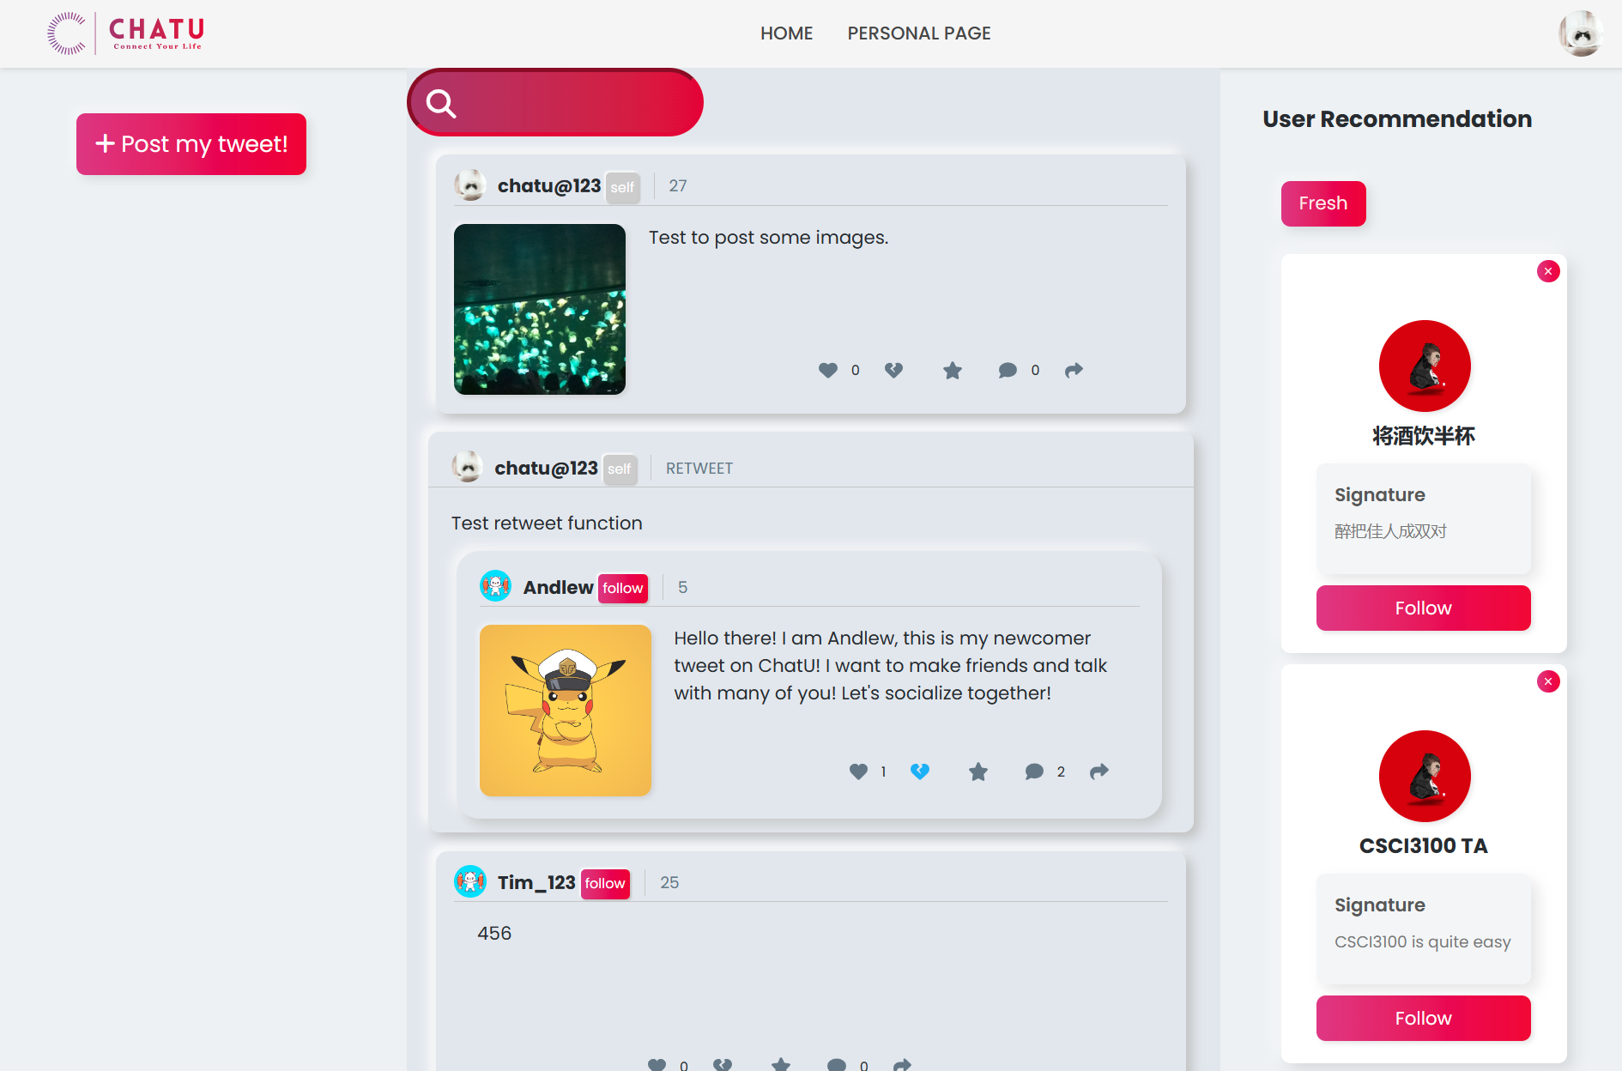

* + 1. Purpose: Test if a non-loginned user cannot do 2.4.3 to 2.4.13.
       1. Input

Directly use the URL to enter the homepage without login.

* + - 1. Expected Output

An error message.

* + - 1. Result

